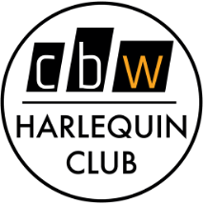

PHOTO/VIDEO RELEASE FORM

Student participation in any media coverage is voluntary and at the student’s and/or parents’ own initiative and will have no effect on a student’s membership status in The Harlequin Club.

Professional publicity photos (cast photos) and videos (typically student made) are frequently used to promote our shows both in print in the school’s lobby display case, in local publications and on social media (Instagram, Facebook and Tik Tok) using our Harlequin Club page/handle.

Photos, video and audio recording of students will only be taken and used in context of the Harlequin Club’s theatre activities in auditions/rehearsals/performance, for promotion of our theatrical performances/activities and for archival purposes for other club activities like the end of year banquet skits, CBSD open house show photos and theatre festivals/workshops/trips.

I hereby give my full and complete permission, for my child to be photographed, (still or motion), and/or tape-recorded, (audio or video), within the context of Harlequin Club Theatrical activities.

STUDENT’S NAME ___________________________________________
PARENT/GUARDIAN NAME ___________________________________________
PARENT/GUARDUIAN SIGNATURE: _______________________________________

